Using The Efofex Word Toolbar & Parameters
Practise Document
This document allows you to practise using the new Word toolbar and Efofex Parameters. The example questions begin on page 3
- Open FX Draw and FX Equation on your computer.
Editing An Existing Graphic
- Select any graphic or equation in the document.
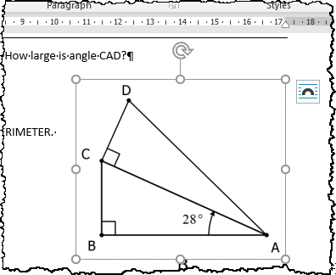
- Push the Edit button.
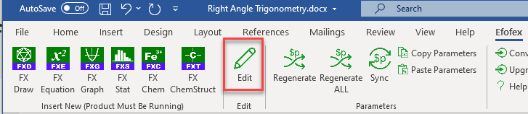
- When you have completed the edit, push the green check mark button to return your new graphic.
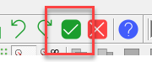
Creating A New Graphic
- Move to a location in the document where you want your new graphic or equation.
- Push either the FX Draw or FX Equation button.
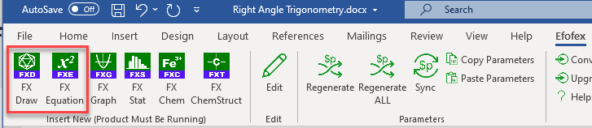
- Create your graphic
- Push the green check mark button to return your graphic to Word.

Regenerating All The Questions
In this document, only questions 1 and 5 contain regeneratable parameters. To regenerate these two questions:
- Push the Regenerate All button
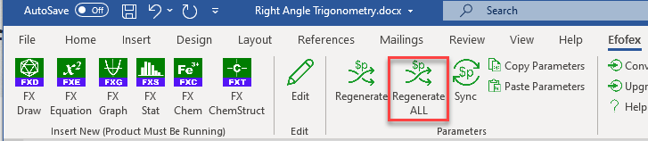
- Wait. Word will tell you when it is finished.
Even though only questions 1 and 5 contain regeneratable parameters, there are over 40 000 different combinations that can be produced.
- Check the output
Regenerate One Question
To regenerate one question, say question 5:
- Select one graphic or equation that forms part of the question 5 or its answer.
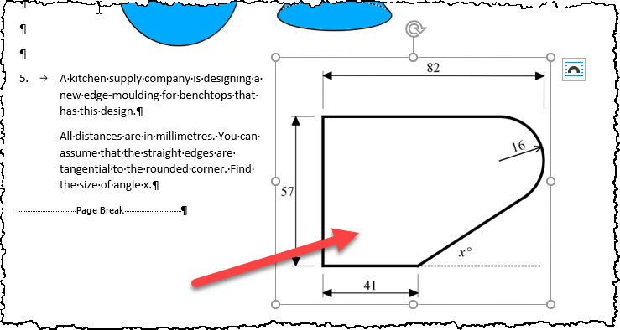
- Push the Regenerate button
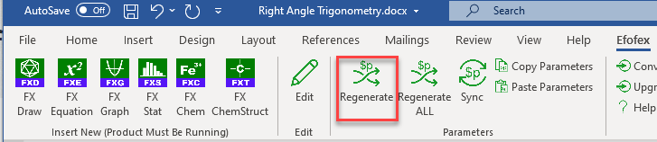
- Wait. Word will tell you when it is finished.
- Check the output.

That is all you need to know to USE a dynamic mathematics document containing Efofex Parameters.

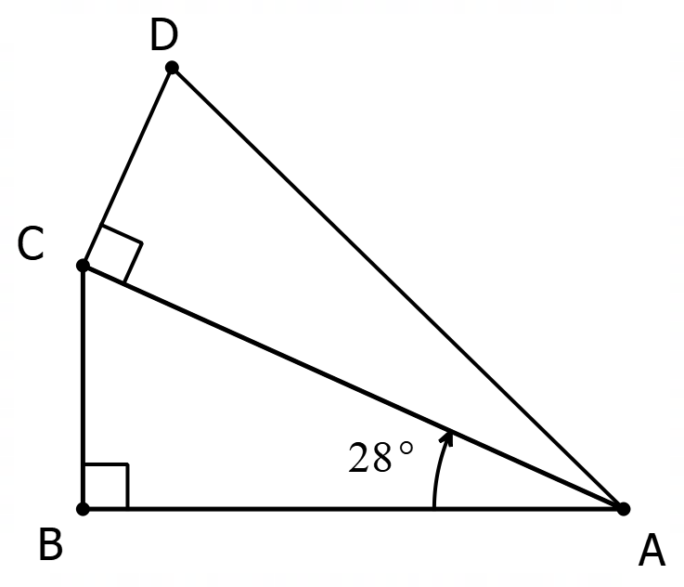
Right Angle Trigonometry – Challenge Questions
1. The two triangles below have the same area. How large is angle CAD?

2. This time, the two triangles have the same PERIMETER. Again, how large is angle CAD?

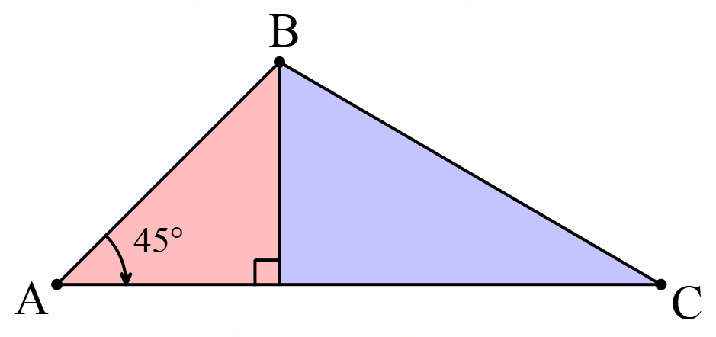

3. This triangle has been divided so that the area of the blue (right) side is 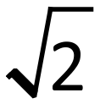 times the area of the red (left) side. What are the angles of triangle ABC?

4. A cone is produced by removing a quarter of a circle and joining the two edges. When you look at the code from the side, what angle is formed by the two sloping sides?
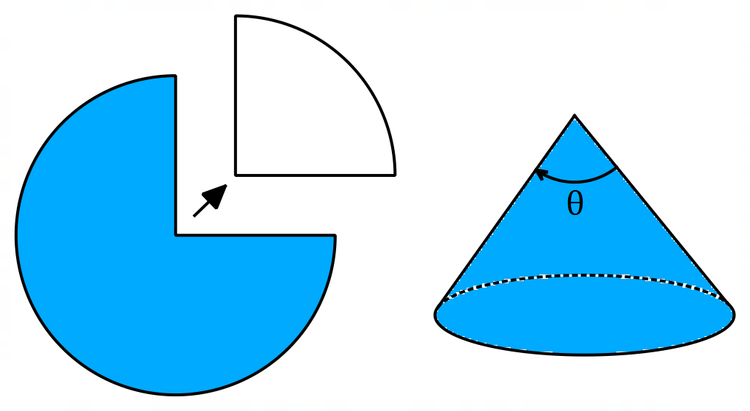

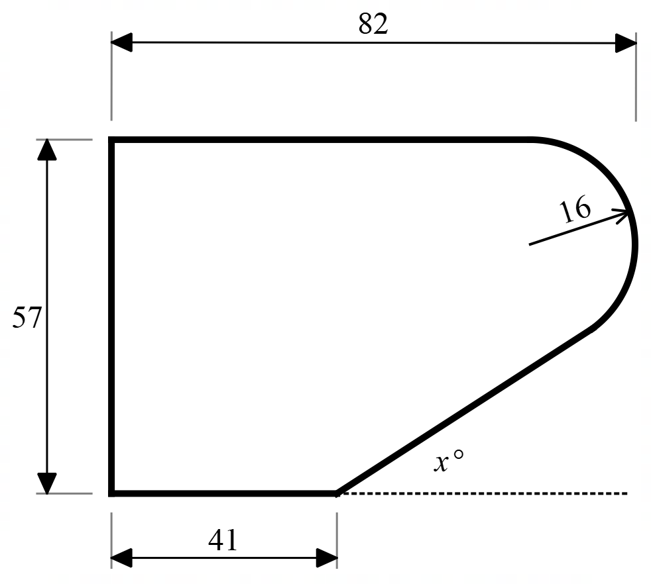
5. A kitchen supply company is designing a new edge-moulding for benchtops that has this design.
All distances are in millimetres. You can assume that the straight edges are tangential to the rounded corner. Find the size of angle x.

Right Angle Trigonometry – Challenge Questions - Answers
- 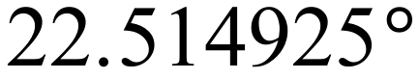
- 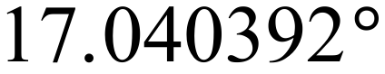
- 45°, 35.3° and 99.7°
- 97.2°
- 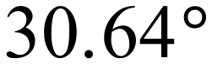

Right Angle Trigonometry – Challenge Questions - Solutions
1. The two triangles below have the same area. How large is angle CAD?
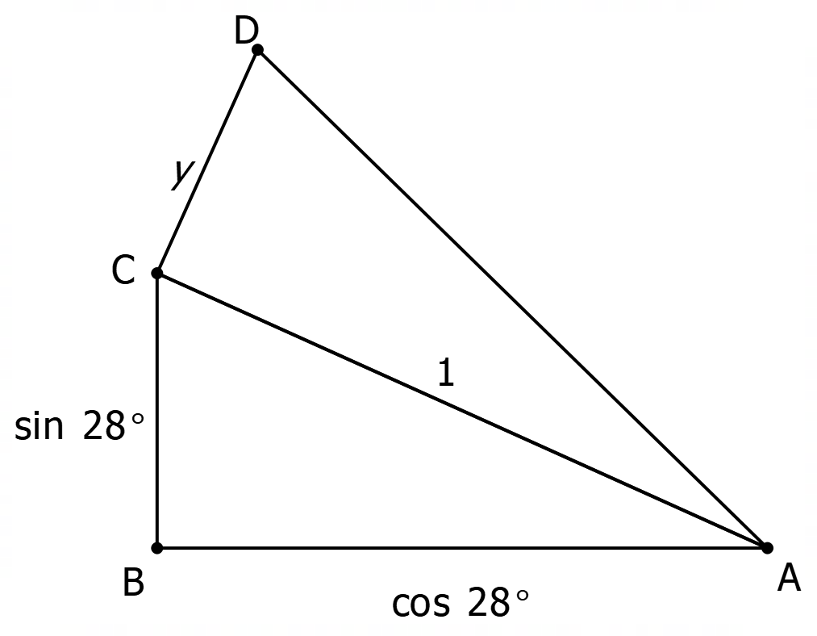
`
The best way to start this question is make one of the sides a standard length. In this case the best way is to make AC = 1. The other sides then determined relative to this.
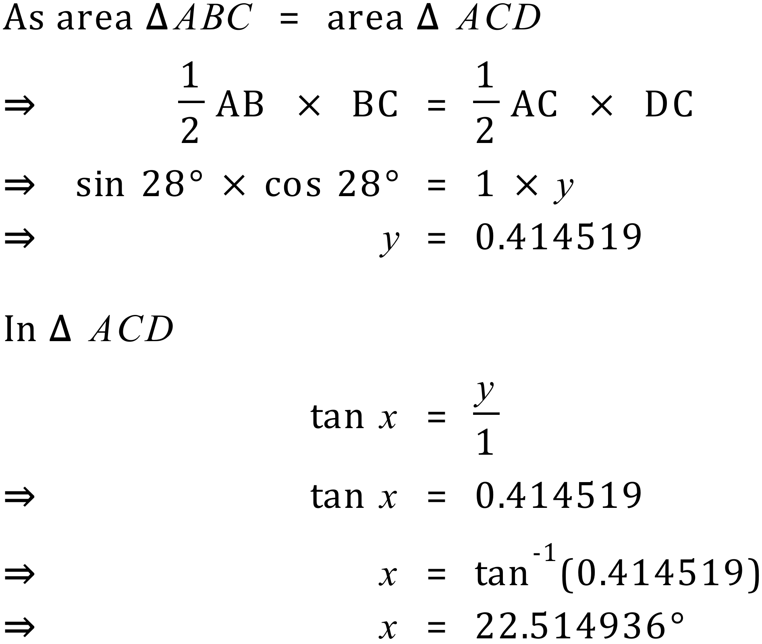

2. This time, the two triangles have the same PERIMETER. Again, how large is angle CAD?

In this question we use the same technique of setting the length of one side. In this case we need an extra side, z.
Using Pythagoras.
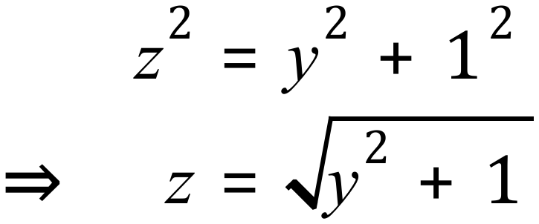
Because the perimeters of the triangles are the same
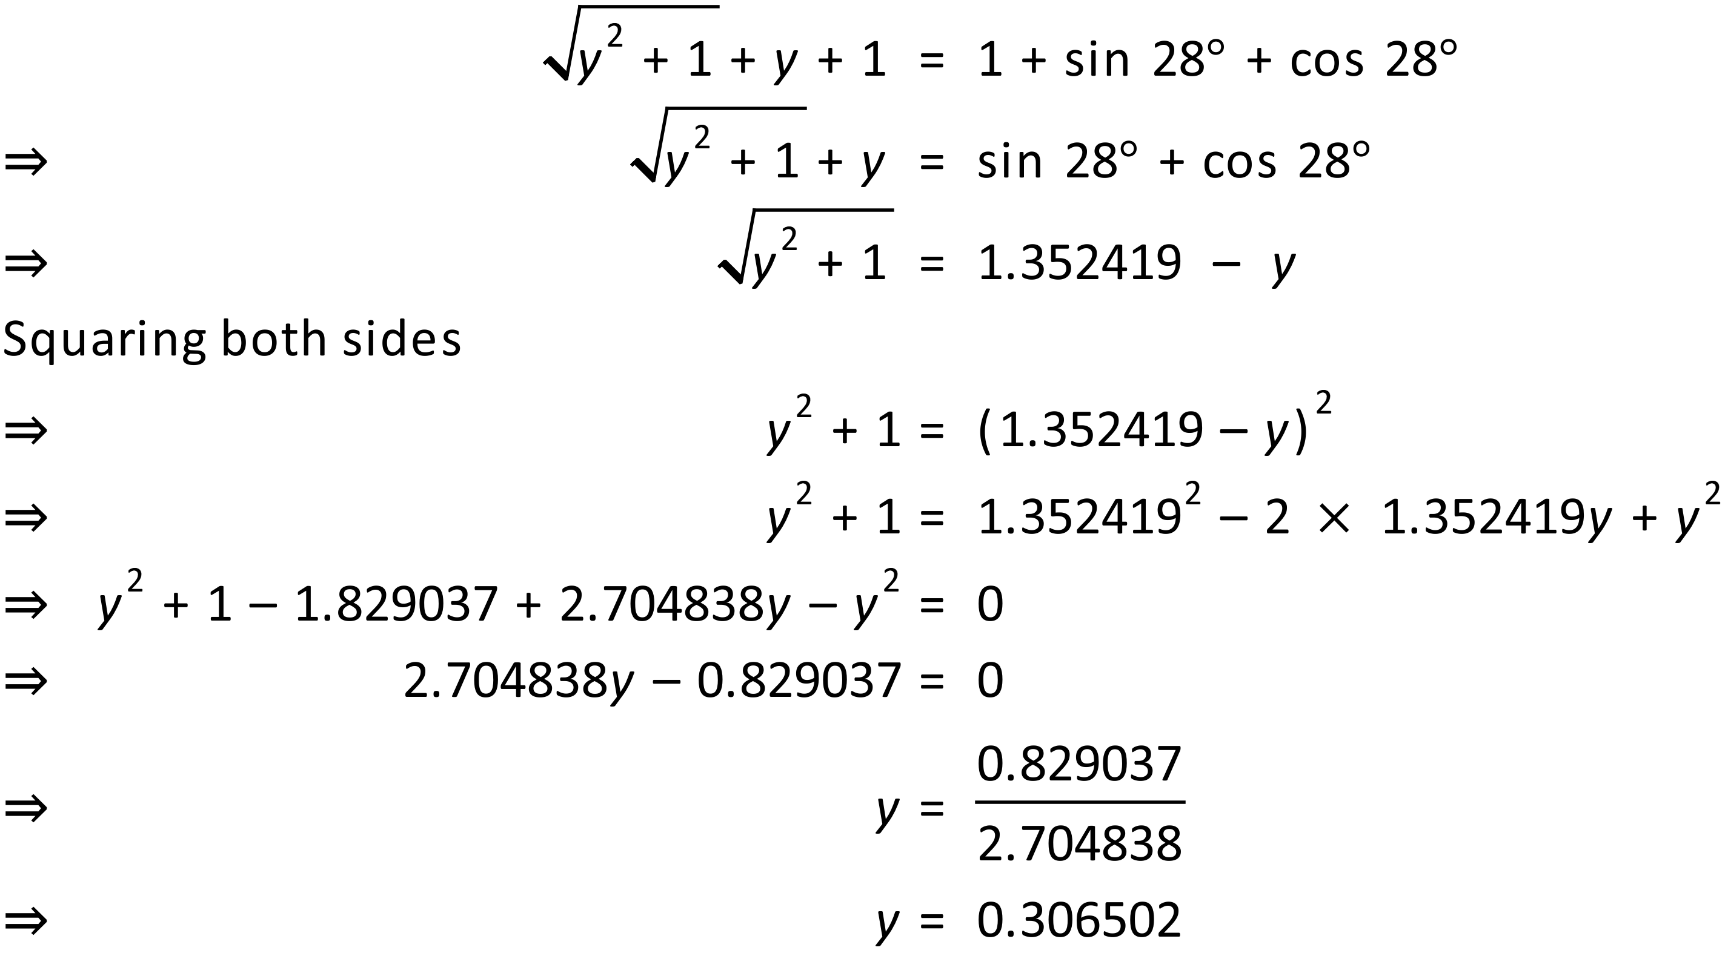
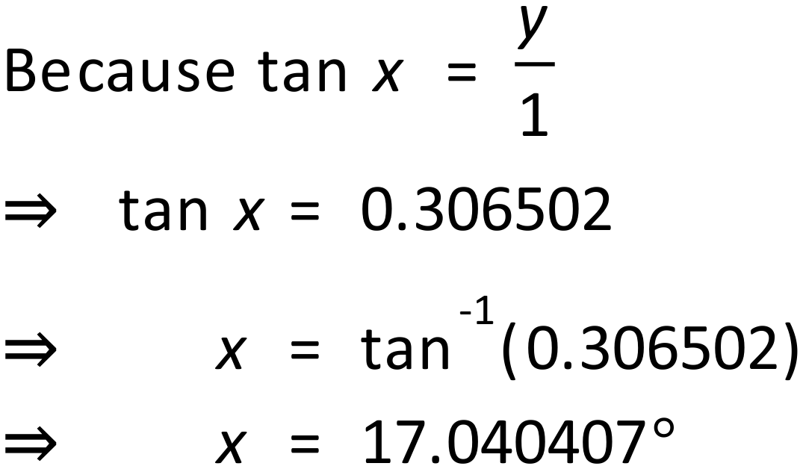
Therefore angle CAD is approximately degrees.
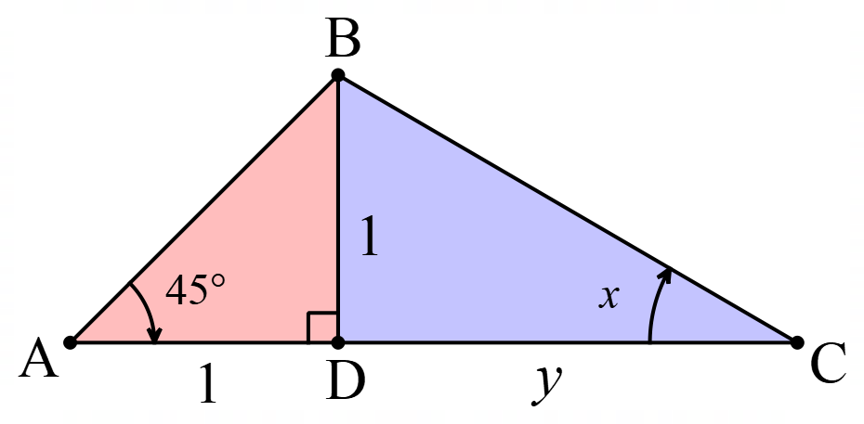

3. This triangle has been divided so that the area of the blue (right) side is 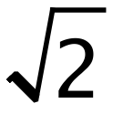 times the area of the red (left) side. What are the angles of triangle ABC?

Assume sides to be one as shown.
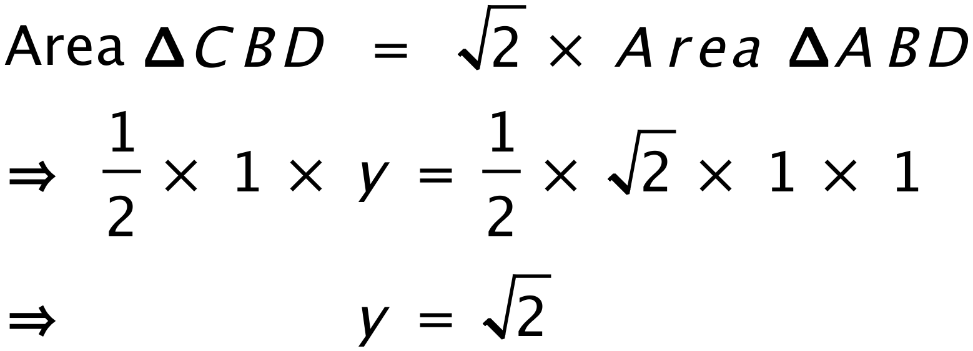
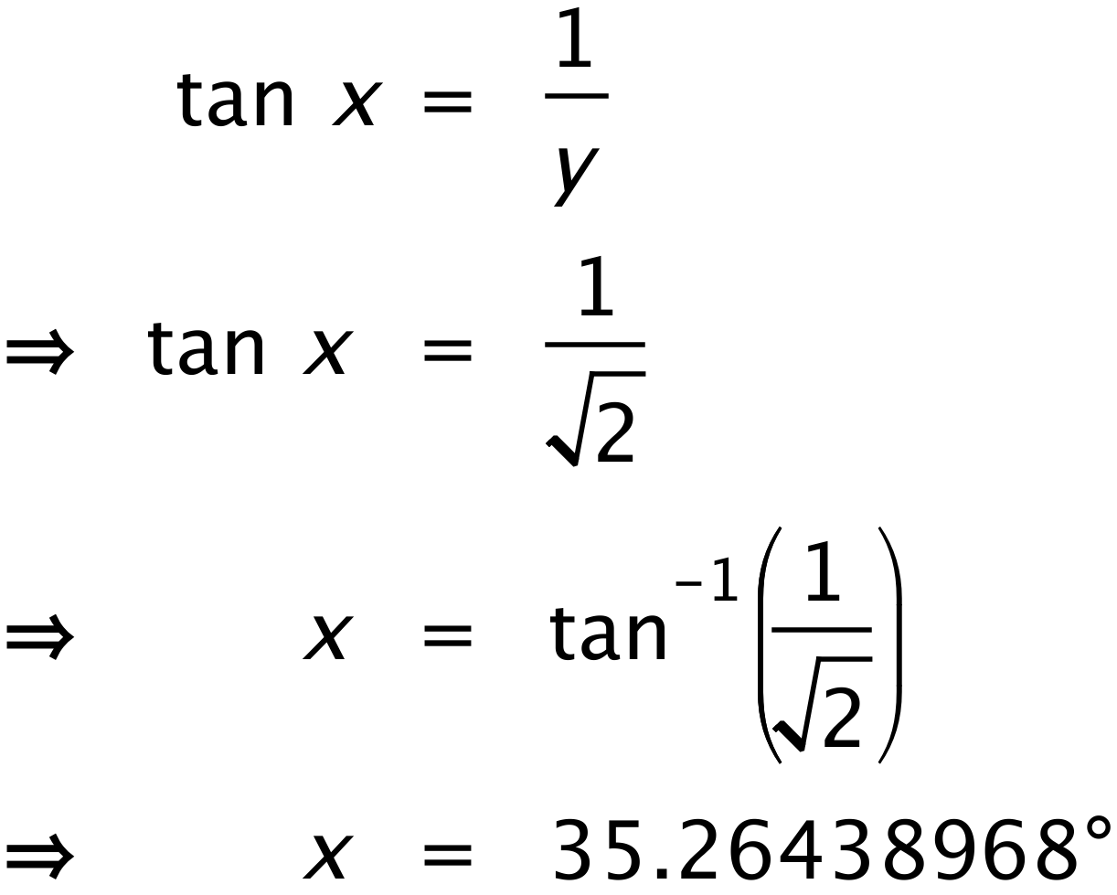 Angles are 45°, 35.3° and 99.7°

4. A cone is produced by removing a quarter of a circle and joining the two edges. When you look at the code from the side, what angle is formed by the two sloping sides?
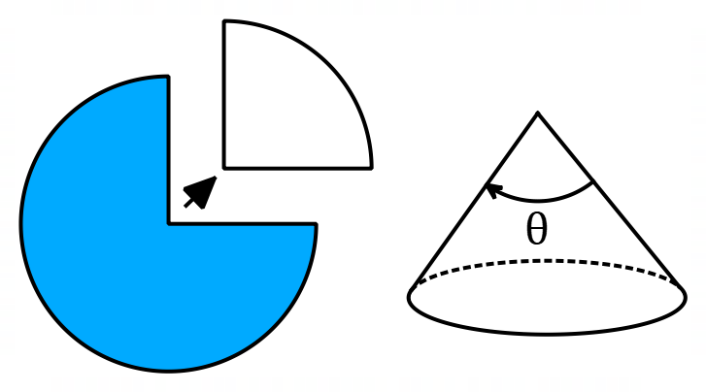
Assume that the radius of the original circle = 1
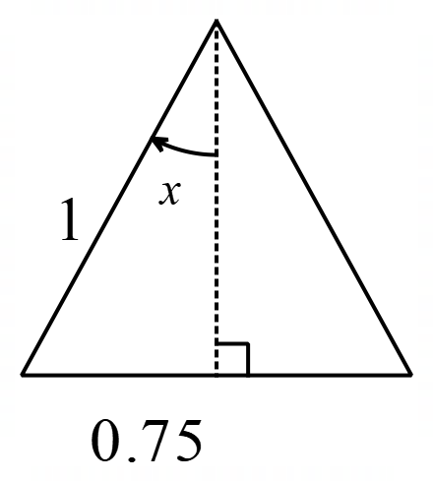
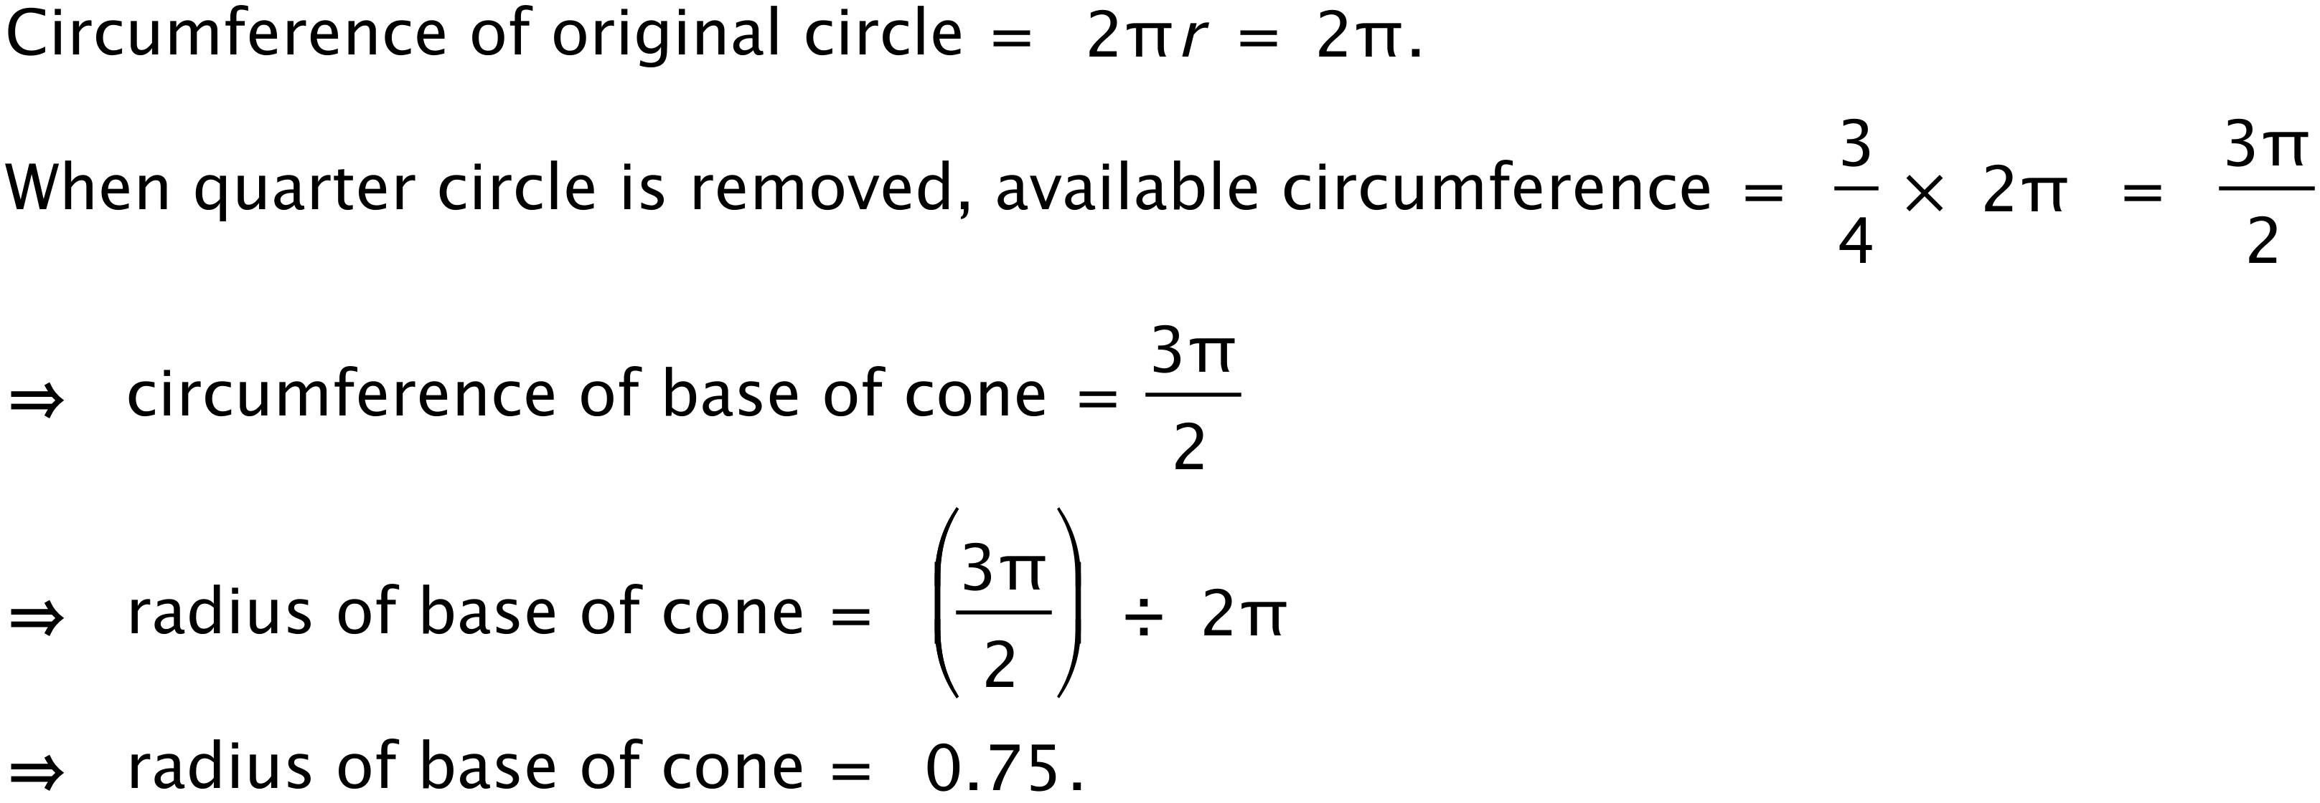

On this cross section of the cone you can see the radius of the base and the radius of the original circle which becomes the slope height of the cone.
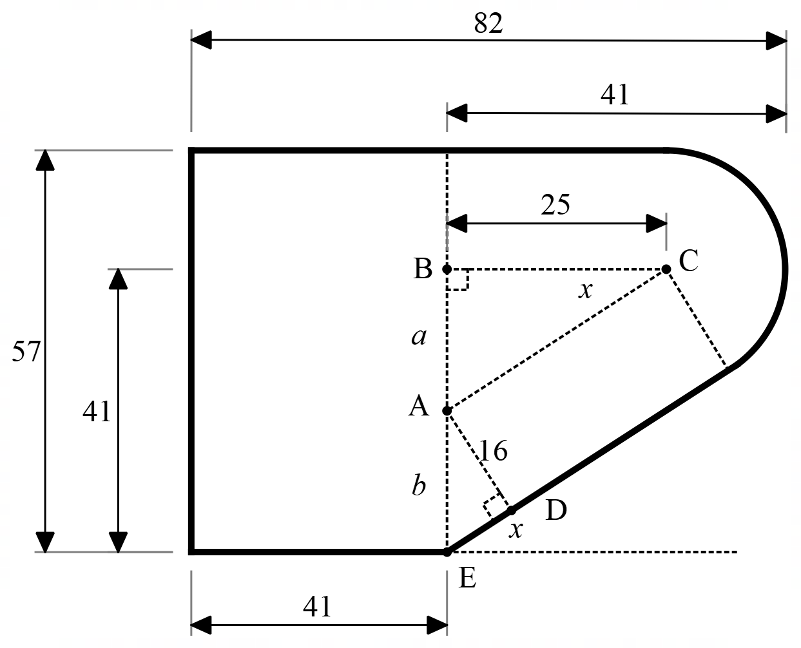
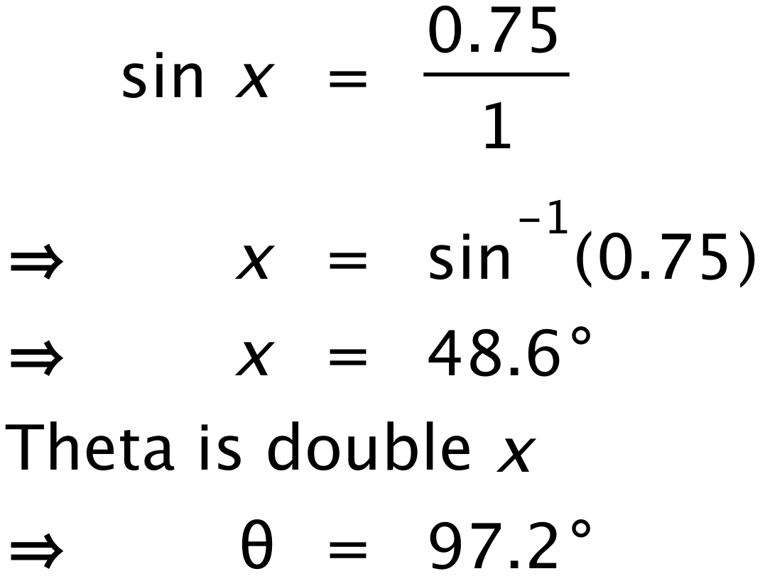
5. An kitchen supply company is designing a new edge-moulding for benchtops that has this design.
All distances are in millimetres. You can assume that the straight edges are tangential to the rounded corner. Find the size of angle x.

The solution to this question requires you to add a lot of extra lines to the diagram. From the diagram, with a little geometry, you can show that triangle ADE is similar to triangle CBA. You use this to solve the question.
