Upgrading Modern Mode Graphics
Practice Document
This document allows you to practise using the new Word toolbar to upgrade Modern Mode graphics to our new toolbar system. The example questions begin on page 2
- Open any relevant Efofex products on your computer.
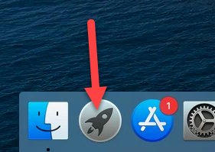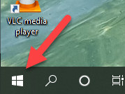
- Push the Upgrade Modern Graphics button.
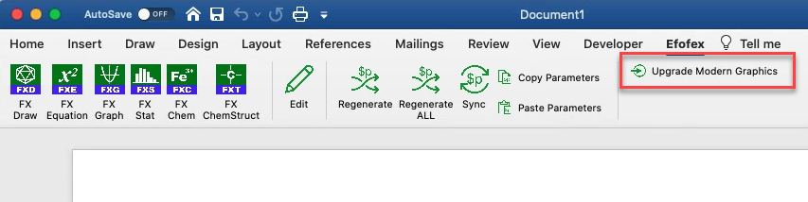

- Wait until the tool reports that upgrading is complete. Please note that upgrading Modern Mode graphics can take some time.
Notes:
- If your computer is set up to block Internet connectivity for our products (this usually occurs in school settings), our products will not be able to download the appropriate data from the Efofex servers and the process will fail. This is unlikely to be a problem for graphics YOU have created.

Congruent Halves
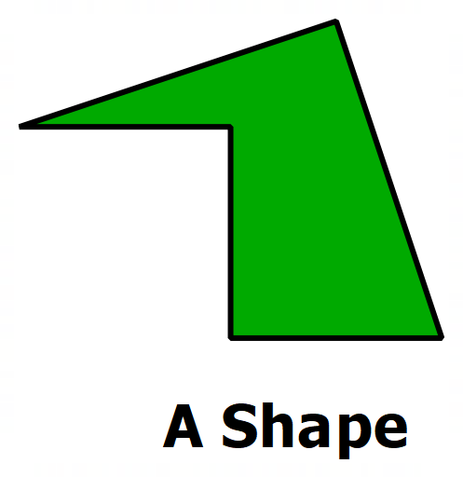 | 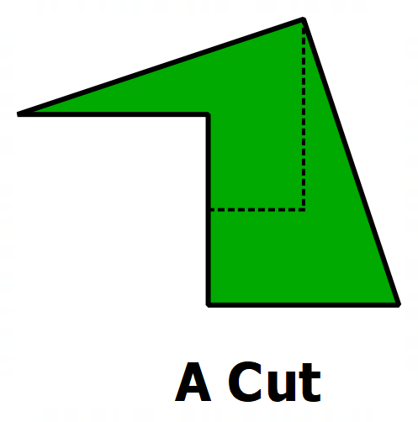 | 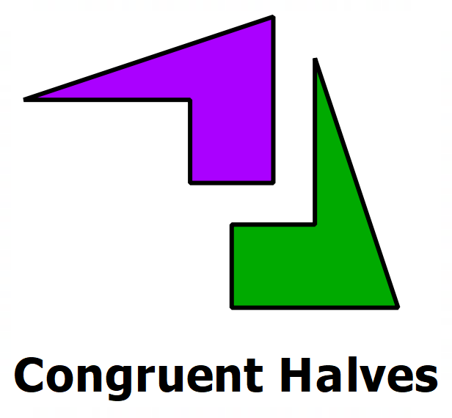
How many can you do?
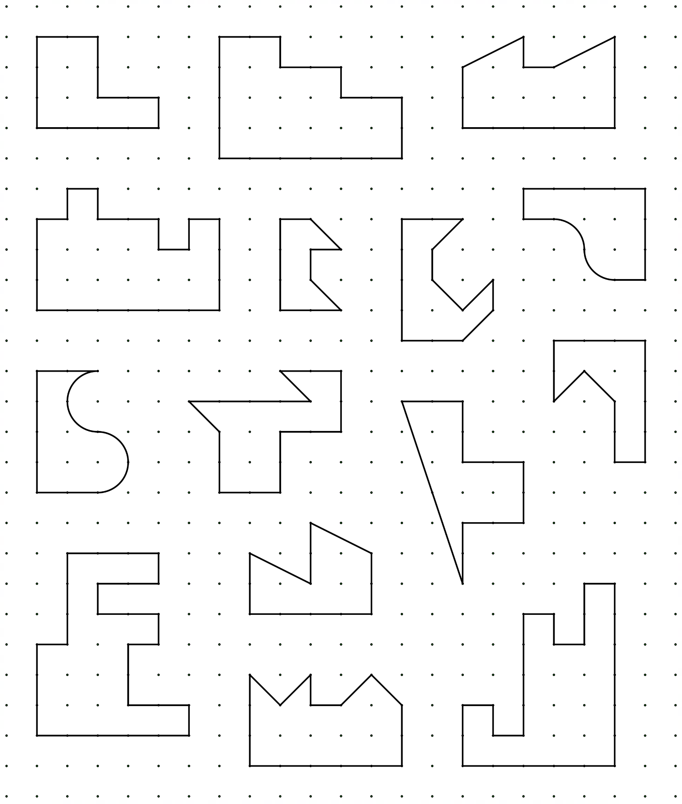
Congruent Halves - Answers
